Analyzing User's Responses To Whatsapp Status Updates: An Empirical Research Study

Ruchi Upadhyay1 , Dr. Devendra Singh2

Research Scholar1 & Assistant Professor2

1,2Department of Education, H.N.B. Garhwal University (A Central University), Srinagar Garhwal, Uttarakhand (India).

Corresponding Author: Dr. Devendra Singh (Email Id: [devendra.singh060@gmail.com](mailto:devendra.singh060@gmail.com))

|  |
| --- |
| **ABSTRACT**  Humans were genetically evolved better than any other species of universe in every aspect. Due to the ability to communicate with each other they can adapt to harsh conditions. Their language development brings many benefits to mankind. Talking to other humans is a fundamental aspect of human existence, offering emotional support, personal growth, and a sense of connectedness. Meaningful interactions with others are vital for maintaining mental and emotional well-being, fostering positive relationships, and thriving in various aspects of life. Today is the age of technology and it affects the mode of human communication such as we use social networking sites to share our feelings and emotions. One such platform is WhatsApp, most people communicate with their family, friends, and relatives through WhatsApp, share everything related to his or her life by updating WhatsApp Status. Through this study researcher analyses the responses on WhatsApp Status Updates using a An Empirical research design. Data was collected naturally and randomly continuously throughout one year from all the people on researcher’s contact list approximately around 600, and their responses on different contexts updated on WhatsApp Status were observed time to time. After collecting all the data, the final work of analyzing was done. Results show that among Emotional sentiments, Political, Social Issues, Environmental, Academic Achievement, Personal Advice, Humorous, Medical, Economical and Psychological support context, Academic Achievement context receive highest responses, and Political context receive lowest responses from Family, Friends, Teachers, Relatives, and Students of the researcher. Overall, what percentage of responders from each category for all contexts is also measured at the end for better understanding.  **Keywords:** Responses, Social networking, WhatsApp Status Updates, Social-Psychological support, and Empirical Research Method. |

**INTRODUCTION**

Man is a social being; he continuously learns from his environment and by the interaction with other humans in that environment. As he is inherently a social creature, and meaningful interactions with others offer a wide range of benefits that positively impact various aspects of his life. He is an inseparable part of the social groups in which he stays. He should be active in his social groups like with family members, Neighbours, friends, peer- groups and other members of the society. His emotional, social, mental and physical development directly depends on his involvement with other humans and thus he grows as an individual personality. As a person shares his feelings with others, he gets feedback and thus he tries to change himself for the better. It is a fundamental aspect for human existence, offering emotional support, personal growth, and a sense of connectedness. Meaningful interactions with others are vital for maintaining mental and emotional well-being, personal growth fostering positive relationships, and thriving in various aspects of life.

The way in which humans communicate with each other has been continually evolving and developing over time. Historical events, changes in social norms, cultural shifts, technological advancements, and economic developments play a crucial role in this evolution. In prehistorical times, human interaction was primarily limited to small tribal communities with face-to-face verbal communication and nonverbal cues. With the development written language emerged, enabling people to communicate across distances and preserve knowledge. The invention of the printing press, ideas and knowledge were spread on a large scale by making books more accessible. With the advancement of technologies, long-distance instant communication has taken place through the telegraph and later the telephone. Due to the invention of radio, television, and mass media, the 20th century witnessed transformative developments in communication as this invention facilitated information exchange at global level and affects public opinion. In the late 20th century and early 21st century the advancements of internet and digital technologies revolutionized human interaction. Email, instant messaging, social media, and video conferencing transformed the way of people's communication, collaboration, and socialization.

The widespread adoption of mobile phones has further enhanced communication by enabling people to stay connected, making it more convenient and accessible for all. Today's society is heavily influenced by social media, with technology becoming an integral part of everyone's daily life **(Raghavendra et al., 2018)**. Social media platforms have emerged as new avenues for individuals to interact, share, and engage with others globally, transforming how individuals, organizations, and communities create, share, and utilize information **(Baccarella et al., 2018)**. People establish social networks and relationships online to connect with others who share similar interests, backgrounds, activities, or real-life connections **(Akram and Kumar, 2017)**. Through social media, people can share knowledge and advice (**Oh et al., 2013),** and online communities form around shared interests, hobbies, and causes. In recent decades, social media has had an unprecedented impact on people's lives **(Goel and Gupta, 2020)**.

We are not exaggerating when we say that smartphones have become akin to a flood, sweeping most people away in comparison to other technological devices **(Klimsa et al., 2006; Al-Smadi, 2017; Castells, Fernandez-Ardevol, Qiu, & Sey, 2006).** Social media users between the ages of 18 and 35 spend a minimum of two hours online daily, either to communicate with others, stay updated, or simply to mindlessly scroll through their newsfeeds, consuming almost a quarter of their day **(Khaleej Times, 2016)**. The growing importance of WhatsApp as a means of communication is evident, as WhatsApp users often express their thoughts, emotions, or ideas through their smartphone's status updates. It is undeniable that these statuses are viewed by the users' followers. **Al-Khawaldeh, Bani-Khair, Mashaqba, Huneety (2016)** indicated in their study that WhatsApp statuses reveal personal, social, religious, and political issues that concern the users. This application is a free downloadable messenger that uses the internet to send instant multimedia messages, available on almost all smartphones. To utilize this application, the user must have an internet connection and the application downloaded on their smartphone. Brain Acton and Jan Koum, former employees of Yahoo!, founded the application in 2009, which is now owned by Facebook. Initially starting with a small user base, it quickly grew to 250,000 users within a few months and currently boasts over 700 million users, making it the largest online messenger application **(Bouhnik & Deshen, 2014)**.

This study was conducted to analysis the user's response to WhatsApp status updates with the help of an Empirical research design.

**Aim of the study**

This paper aims to investigate the responses to WhatsApp statuses from both social and psychological perspectives. It seeks to analyze the responses to WhatsApp statuses across different dimensions and examine the attitudes of the responders towards them.

**Questions of the study**

The research will answer the following questions:

1. How do people express their feelings to users’ states through WhatsApp statuses?

2. What are the social and psychological support user gets by these WhatsApp statuses?

3. To what extent are these statuses able to seek attention?

**METHODS**

**Research Design**

The researchers spent 12 months collecting the data for the study by self- participation and observed the responses on WhatsApp statuses. Empirical research design was used in this study. The data were collected both naturally and randomly. The identities of the responders remain top confidential.

**Data Analysis**

In this study data collected by observation method was analyzed with the help of descriptive statistics according to the nature and need of the study by the researcher.

**RESULTS AND DISCUSSIONS**

The researchers analyzed the responders’ responses that express their feelings on WhatsApp statuses. Then the responses were identified and analyzed into different aspects.

**Table 1:** Responses user gets on the WhatsApp statuses containing different context

|  |  |  |  |  |  |  |  |
| --- | --- | --- | --- | --- | --- | --- | --- |
| **S.No.** | **Context** | **Status type** | **Total number of Contacts** | **Number of people seen status** | **Number of Responders** | **Percentage** | |
| **of people seen status** | **of total Contact** |
| 1. | Emotional sentiments | Heartbreak in love life | 600 | 140 | 57 | 40.71 % | 9.5% |
| 2. | Political | Wishes of Independence Day | 560 | 109 | 10 | 9.17 % | 1.78% |
| 3. | Social Issues | Focus on current issues | 580 | 198 | 51 | 25.75 % | 8.79% |
| 4. | Environmental | Awareness about environmental protection. | 570 | 165 | 16 | 9.69 % | 2.80% |
| 5. | Academic Achievement | Share work progress | 599 | 159 | 89 | 55.97 % | 14.85% |
| 6. | Personal Advice | Ask help in self Evaluation | 610 | 195 | 12 | 6.15% | 1.96% |
| 7. | Humorous | share a funny picture | 565 | 193 | 62 | 32.12 % | 10.97% |
| 8. | Medical | Put a status on Urgent need for blood donation | 605 | 137 | 60 | 43.79 % | 9.91% |
| 9. | Economical | Ask help for some money | 578 | 203 | 28 | 13.79 % | 4.84% |
| 10. | Psychological support | Express feeling of anxious and depressed | 589 | 205 | 21 | 10.24 % | 3.56% |

The following charts show the results of Responses user gets on the WhatsApp statuses of different context: -

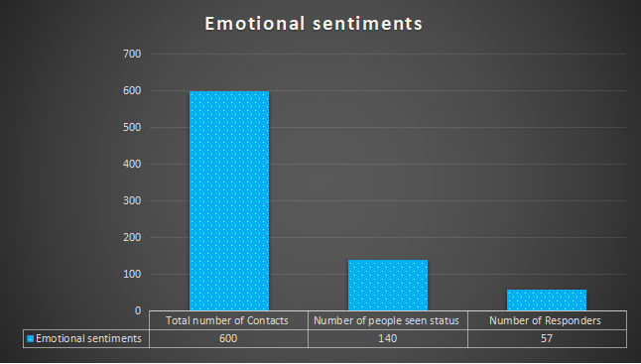

**Figure 1:**  Responses on Emotional sentiments WhatsApp status.

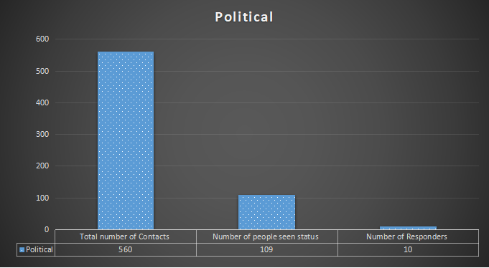

**Figure 2:** Responses on Political WhatsApp status.

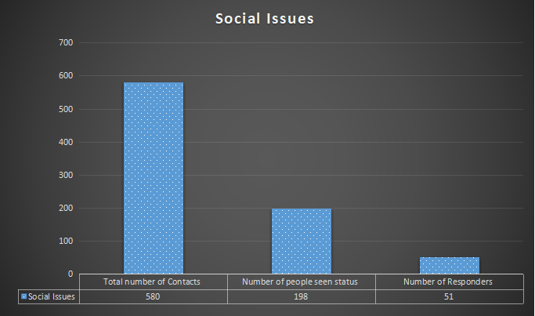

**Figure 3:** Responses on Social Issue WhatsApp status.

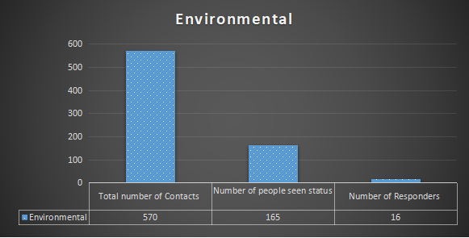

**Figure 4:** Responses on Environmental WhatsApp status.

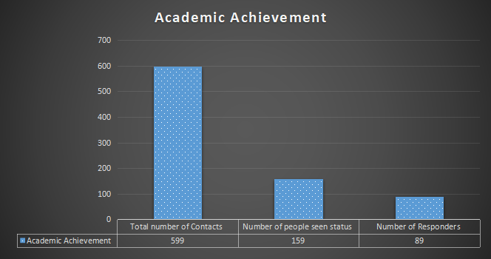

**Figure 5:** Responses on Academic Achievements WhatsApp status.

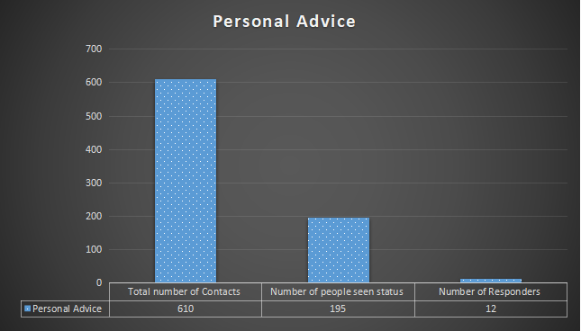

**Figure 6:** Responses on Personal Advice WhatsApp status.

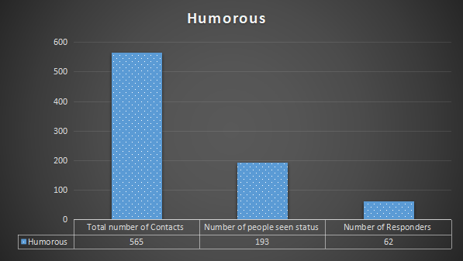

**Figure 7:** Responses on Humorous WhatsApp status.

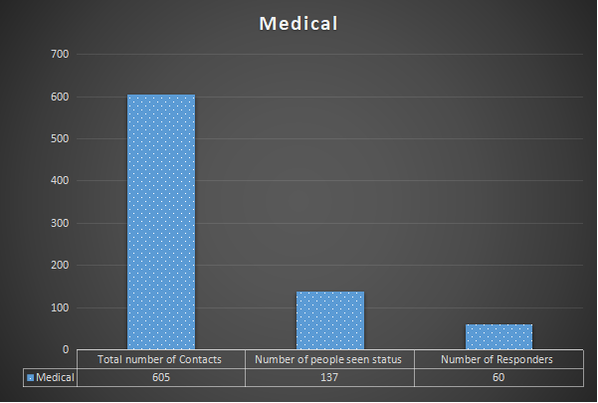

**Figure 8:** Responses on Medical WhatsApp status.

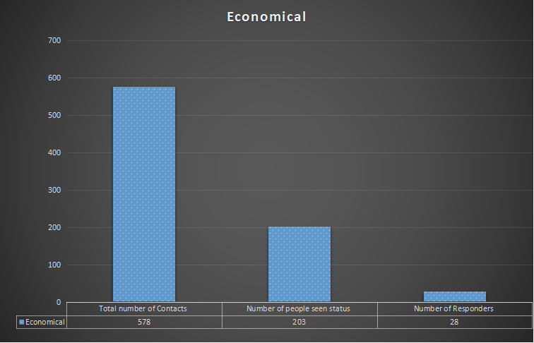

**Figure 9:** Responses on Economical WhatsApp status.

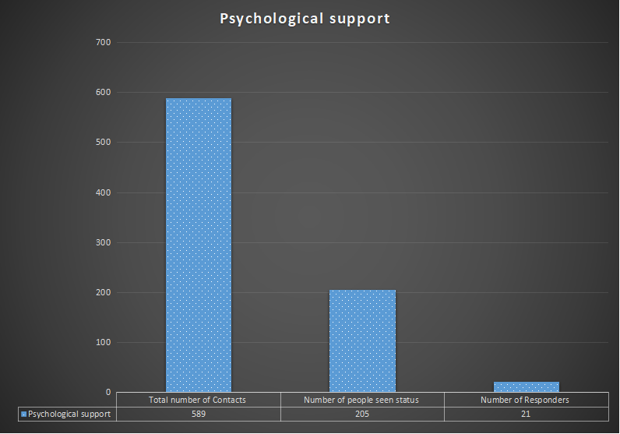

**Figure 10:** Responses on psychological Support WhatsApp status.

**Context wise analysis of responses**

**Emotional sentiments –** Researcher put a sad poem sharing feelings of heartbreak in love life on WhatsApp status and observe the response of people seen that poem. It was observed that out of 600 contacts number saved on cellphone of the researcher 140 people have seen the WhatsApp status and 57 people give their responses out of these 140 people which was only 40.71 % of people seen the status and 9.5% of total people on contact list.

**Political –** When researcher wish happy Independence Day through WhatsApp status, it was observed that out of 560 people on contact list 109 people seen the status and only 10 people gave their response by wishing back which was 9.17 % of people seen the WhatsApp status and 1.78% of total people on contact list.

**Social Issues -** In social context 198 people seen the status out of 580 and 51 responders gives their responses after seeing current social issues shared by the researcher through WhatsApp status which was 25.75 % of people seen the WhatsApp status and 8.79% of total people on contact list.

**Environmental –** When researcher aware about environmental protection through WhatsApp status, out of 570 contacts number saved on cellphone of the researcher 165 people have seen the WhatsApp status and 16 people give their responses which was only 9.69 % of people seen the status and 2.80% of total people on contact list.

**Academic Achievement –**When researcher share achievement news related to academic progress through WhatsApp status, it was found that out of 599 contacts number saved 159 people have seen the WhatsApp status and 89 people give their responses by congratulating the researcher which was 55.97 % of people seen the status and 14.85% of total people on contact list.

**Personal Advice -** In the context of personal advice 195 people see the WhatsApp status of researcher out of 610 and 12 people responded by giving their advice which was 6.15% of people seen the WhatsApp status and 1.96% of total people on contact list.

**Humorous -** Researcher shares a funny picture with a humorous joke on WhatsApp status. It was observed that out of 565 contacts number saved on cellphone of the researcher 193 people have seen the WhatsApp status and 62 people give their responses out of these 193 people which was 32.12 % of people seen the status and 10.97% of total people on contact list.

**Medical –** Researcher put a status on WhatsApp of urgent need for blood donation needed for an emergency. It was observed that out of 605 people on contact list 137 people seen the status and 60 people gave their response which was 43.79 % of people seen the WhatsApp status and 9.91% of total people on contact list.

**Economical –** When researcher ask help and share urgent need of some money throughWhatsApp status, out of 578 people on contact list, 203 have seen that status and 28 people respond after seeing it which was 13.79 % of people seen the WhatsApp status and 4.84% of total people on contact list.

**Psychological support –** When researcher expressed feelings of anxiousness and depression through WhatsApp status. It was observed that out of 589 people on contact list 205 people have seen the WhatsApp status and 21 people give their responses and asked about the researcher's condition and showed their concern, which was 10.24 % of people seen the status and 3.56% of total people on contact list.

**Category wise analysis of responses user gets**

The following table shows the details of categories of people who responded on the WhatsApp status and their percentage.

|  |  |  |  |  |  |  |  |
| --- | --- | --- | --- | --- | --- | --- | --- |
| S. No. | Context | Family | Friends | Teachers | Relatives | Students | Total People responded |
| 1. | Emotional sentiments | 11 | 25 | 1 | 2 | 18 | 57 |
| 2. | Political | 0 | 3 | 2 | 0 | 5 | 10 |
| 3. | Social Issues | 0 | 35 | 5 | 2 | 9 | 51 |
| 4. | Environmental | 1 | 4 | 2 | 1 | 8 | 16 |
| 5. | Academic Achievement | 13 | 31 | 14 | 3 | 38 | 89 |
| 6. | Personal Advice | 4 | 4 | 2 | 0 | 2 | 12 |
| 7. | Humorous | 2 | 15 | 2 | 13 | 30 | 62 |
| 8. | Medical | 15 | 16 | 5 | 4 | 20 | 60 |
| 9. | Economical | 12 | 5 | 0 | 1 | 10 | 28 |
| 10. | Psychological support | 8 | 4 | 3 | 0 | 6 | 21 |

In the emotional sentiments context 57 people responded in total in which 11 belong to family, 25 are friends, 1 is teacher, 2 are relatives and 18 are students of the user. People from Family, Friends, Teachers, Relatives, and Students are 19.29%, 43.85%, 1.75%, 3.50%, 31.57% respectively of total numbers of People responded.

In the Political context 10 people responded in total in which no one in family, 3 are friends, 2 are teachers, zero in relatives and 5 are students from the user contact list. People from Family, Friends, Teachers, Relatives, and Students are 0%, 30.00%, 20.00%, 0%, 50.00% respectively of total numbers of People responded.

In the Social Issues context 51 people responded in total in which zero in family, 35 are friends, 5 are teachers, 2 are relatives and 9 are students of the user. People from Family, Friends, Teachers, Relatives, and Students are 0%, 68.62%, 9.80%, 3.92%, 17.64% respectively of total numbers of People responded.

When it comes to Environmental context 16 people responded in total in which 1 in family, 4 are friends, 2 are teachers, 1 is relatives and 8 are students of the user. People from Family, Friends, Teachers, Relatives, and Students are 6.25%, 25.00%, 12.50%, 6.25%, 50.00% respectively of total numbers of People responded.

In the Academic Achievement context, 89 people responded in total in which 13 are in family, 31 are friends, 14 are teachers, 3 are relatives and 38 are students from the user contact list. People from Family, Friends, Teachers, Relatives, and Students are 14.60%, 34.83%, 15.73%, 3.37%, 42.69% respectively of total numbers of People responded.

In the Personal Advice context, 12 people responded in total in which 4 are in family, 4 are friends, 2 are teachers, no one in relatives and 2 are students from the user contact list. People from Family, Friends, Teachers, Relatives, and Students are 33.33%, 33.33%, 16.66%, 0%, 16.66% respectively of total numbers of People responded.

When it comes to Humorous context 62 people responded in total in which 2 in family, 15 are friends, 2 are teachers, 13 are relatives and 30 are students of the user. People from Family, Friends, Teachers, Relatives, and Students are 3.22%, 24.19%, 3.22%, 20.96%, 48.38% respectively of total numbers of People responded.

In the Medical context, 60 people responded in total in which 15 are in family, 16 are friends, 5 are teachers, 4 are relatives and 20 are students from the user contact list. People from Family, Friends, Teachers, Relatives, and Students are 25.00%, 26.66%, 8.33%, 6.66%, 33.33% respectively of total numbers of People responded.

In the Economical context, 28 people responded in total in which 12 are in family, 5 are friends, zero teachers, 1 in relatives and 10 are students from the user contact list. People from Family, Friends, Teachers, Relatives, and Students are 42.85%, 17.85%, 0%, 3.57%, 35.71% respectively of total numbers of People responded.

In the last context psychological support, 21 people responded in total in which 8 are in family, 4 are friends, 3 are teachers, zero in relatives and 6 are students from the user contact list. People from Family, Friends, Teachers, Relatives, and Students are 38.09%, 19.04%, 14.28%, 0%, 28.57% respectively of total numbers of People responded.

**CONCLUSION**

An Empirical Research Study was performed by the researcher to analyses responses to WhatsApp Status Updates which gives the insight to people's feelings to users’ states through WhatsApp statuses and how they responded on different context such as on Emotional sentiments, Political, Social Issues, Environmental, Academic Achievement, Personal Advice, Humorous, Medical, Economical and Psychological support context. It was found that researchers get the highest responses on Academic Achievement, Medical and Emotional sentiments of 55.97%, 43.79 % and 40.71% respectively of the people who seen the WhatsApp status. Researcher gets lowest responses on Environmental, Political and Personal Advice context of 9.69%, 9.17% and 6.15% respectively of the people who seen the WhatsApp status.

It was also observed that in the highest responded context such as Academic Achievement 14.60% are Family, 34.83% are Friends, 15.73% are Teachers, 3.37% are Relatives, and 42.69% are Students. In Medical context 25.00% are Family, 26.66% are Friends, 8.33% are Teachers, 6.66% are Relatives, and 33.33% are Students. Similarly in Emotional sentiments context researcher gets responses of 19.29% of Family, 43.85% of Friends, 1.75% of Teachers, 3.50% of Relatives, and 31.57% of Students.

Overall, it can be concluded that researcher gets different responses on different context of WhatsApp status. Those responses can also be divided into different categories. Every category responded to some of the context and not responded to other context due to their self-made choices.

**SIGNIFICANCE OF THE STUDY**

Communication is the foundation of forming and maintaining relationships. Through talking and active listening, individuals can establish bonds with family, friends, colleagues, and acquaintances, enriching their social network and support system. Sharing thoughts, feelings, and experiences with others can provide emotional support during challenging times.

This study helps in finding the better understanding of people's responses on WhatsApp Status Updates and how it allows individuals to vent their emotions, receive empathy, and feel understood, reducing feelings of isolation and loneliness. It also helps to know what percentage of Family, Friends, Teachers, Relatives, and Students gives responses on WhatsApp Status Updates containing different context as on Emotional sentiments, Political, Social Issues, Environmental, Academic Achievement, Personal Advice, Humorous, Medical, Economical and Psychological support context.

We can easily be able to understand which context receive highest responses, and which one receive lowest responses from Family, Friends, Teachers, Relatives, and Students, which is beneficial for better knowledge of the interaction and sharing through WhatsApp Status Updates in our life. Furthermore, studies adopting an empirical method research design employed in the future is also highly suggested and gets benefits from this research work in area of social networking.

**ACKNOWLEDGEMENT**

First and foremost, I would like to express my gratitude to energetic, hardworking and soft-hearted Prof. Rama Maikhuri (Head & Dean), School of Education H. N. B. Garhwal University (A Central University), Srinagar, Uttarakhand (India). In addition to madam, I would also like to acknowledge to all faculty members of my department to provide me opportunities to boost my interest in research work.

Last but not the least, I would also like to express my gratitude to all the people who participated directly and indirectly in my research work and gives their responses on my WhatsApp Status Updates and helps me to collect the data. Without them this research is impossible to take place.

**REFERENCES**

[1] Akram, W. and Kumar, R. 2017. A study on positive and negative effects of social media on society. International Journal of Computer Sciences and Engineering, 5(10): 351-354.

[2] Al-Khawaldeh, N., Bani-Khair, B., Mashaqba, B., Huneety, A. (2016). A Corpus Based Discourse Analysis Study of WhatsApp Messenger’s Semantic Notifications. International journal of applied linguistics & English literature, 5(6).

[3] Al-Smadi, A. M. (2017). Gender and Age Patterns on WhatsApp Statuses as Used by Jordanians: A Sociolinguistic Perspective. International Journal of English Linguistics, 7(4), 56-66. <https://doi.org/10.5539/ijel.v7n4p56>

[4] Baccarella, C. V. Wagner, T. F. Kietzmann, J. H. and McCarthy, I. P. 2018. Social media? It's serious! Understanding the dark side of social media. European Management Journal, 36(4): 431-438.

[5] Banita & Kaul, Rimple. (2023). Social media: The Usefulness and Aftermath on Society. 8. a139-a149. 10.1729/Journal.32977.

[6] Bouhnik, D., & Deshen, M. (2014). WhatsApp Goes to school: Mobile Instant messaging between Teachers and students. Journal of Information technology Education Research, 217-231.

[7] Castells, M., Fernandez-Ardevol, M., Qiu, J., & Sey, A. (2006). Mobile communication and society: A global perspective. Cambridge, MA: MIT Press.

[8] Gamji, M.B, & Jinaidu, H. S. (2019). Use of WhatsApp as a Learning Tool in Today's Generation: A study of Undergraduate students. International Journal of Information Processing and Communication (IJIPC) Vol. 7 No. 1 [May, 2019], pp. 10-18

[9] Goel, A. and Gupta, L. 2020. Social media in the times of COVID-19. Journal of clinical rheumatology, (6): 220-223.

[10] Khaleej Times. (2016, July 4). UAE residents spend almost a quarter of their day on social media. Retrieved from Khaleej Times: <http://www.khaleejtimes.com/business/technology/uae-residentsspend-almost-aquarter-of-their-day-on-social-media>

[11] Klimsa, P., Colona, G., Ispandriarno, L., Sasinska-Klas, T., Döring, N., & Hellwig, K. (2006). Generation SMS: An empirical, 4 country study carried out in Germany, Poland, Peru, and Indonesia. http://km.meme.hokudai.ac.jp/people/jantke/Publications/2007/2007_TUI-IfMKDB-29.pdf Lakoff, R. (1975). Language and Women’s Place. New York: Harper & Row.

[12] Oh, O. Agrawal, M. and Rao, H. R. 2013. Community intelligence and social media services: A rumour theoretic analysis of tweets during social crises. MIS quarterly, 407-426.

[13] Raghavendra, P. Hutchinson, C. Grace, E. Wood, D. and Newman, L. 2018. “I like talking to people on the computer”: Outcomes of a home-based intervention to develop social media skills in youth with disabilities living in rural communities, Research in developmental disabilities, 76:110-123.

[14] [https://www.google.co.in](https://www.google.co.in/)

[15] [https://www.academia.edu](https://www.academia.edu/)

[16] [https://scholar.google.com](https://scholar.google.com/)

[17] [https://www.researchgate.net](https://www.researchgate.net/)