Challenges Of Grammar Translation Method:

A Perception Of Novice English Language

Teachers Of Secondary Level At Swabi

Aasima Bibi*, Imtiaz Ali**, Laraib Khan***

* M. Phil Scholar, Department of English, Linguistics and

Literature, Qurtuba University of Science and Information Technology,

Hayatabad, Peshawar, Khyber Pukhtunkhwa, Pakistan.

**Department of English, Faculty of Arts and Humanities,

Coventry University, UK

*** M. Phil Scholar, Department of English, Linguistics and Literature,

Qurtuba University of Science and Information Technology, Hayatabad,

Peshawar, Khyber Pukhtunkhwa, Pakistan.

|  |
| --- |
| Abstract This paper investigates the perception and attitude of novice EL teachers towards the Grammar Translation Method (GTM) in comparison to the Direct Method (DM). English language teaching (ELT) has become a central focus of educationists as English language received the status of international language and regarded English, a symbol of advancement in Pakistan. Language teaching needs a separate skill set and expertise to produce successful language learners. ELT uses different teaching methodologies for its learners; the most widely used among them are the Grammar Translation Method (GTM) and the Direct Method (DM). GTM focuses on linguistic competence while DM focuses on linguistic performance, both use different pedagogical techniques with each’s own pros and cons. Currently, the direct method is mostly employed in universities for language learning purposes while the majority of the secondary schools of Swabi use GTM traditionally. The novice EL teachers who have been exposed to the Direct method for 4-6 years when getting into the school for English language teaching face problems in pursuing their classrooms in GTM. The results contribute the lexical and contextual meaning which make a measurable contribution in the field of English language teaching (ELT) and literature. There is also room for the future researchers to conduct research in the field of other aspects and expand the analysis to its various types in the field of linguistics as well. Keywords: Grammar Translation Methods, Direct Method, Translation, Teaching ,English Language, Secondary Schools, English Language Teaching (Elt). |

### Introduction

The English language is a lingua franca, and its function extends beyond mere communication as it is used for many other specific purposes such as education, business and technology which has added much to its value. We cannot deny the value of the English language because it has become the primary source of our education (Arif et al., 2021). In the Pakistan’s education context, English is taught as a compulsory subject at the school and college levels. Some schools including public schools use English as a medium of instruction for many subjects like science, mathematics, computer education and history. Thus, in Pakistan, being a compulsory subject and medium of instruction attaches a core value to English in the academic process and English teaching and learning becomes an attention-grabbing matter.

There are several considerable teaching methodologies for teaching English in an English Language Teaching (ELT) classroom namely the Grammar Translation Method (GTM), Direct Method (DM), Audiolingual Method, etc. In Pakistan, GTM has been one of the most widely used English Language teaching techniques at the elementary and secondary levels. GTM is one of the old teaching methodologies which was originally a classical method of language teaching. This method uses the teaching of grammar and translation as essential elements for language teaching. The grammar translation method aims to make the learners able to read and understand the literature of the target language. The main focus of this method is on reading and writing with less focus on speaking and listening (Elmayantie, 2015). GTM helps in enhancing the syntax, vocabulary, and grammar of the learner’s target language (Vinuesa, 2002).

On the other hand, the Direct Method took its way in response to gaps left by GTM as it failed to make the learners efficient speakers and listeners of the target language. The direct method advocates the teaching of the target language in the target language rather than relying on the shoulders of the learner’s native language. The direct method focuses on verbal fluency in the target language (Arif et al., 2021). However, the GTM dominates in lower grades. The proportion of the Direct Method increases with the advancement of the learner’s academic level. It seems like in primary classes the teachers use GTM dominantly as compared to the Direct Method. As the learners advance to higher classes, the teachers tend to use the Direct Method more as compared to GTM. In ELT classrooms, the Direct method dominates GTM at the university level.

It seems that at the time of graduation, the learners get completely used to the Direct Method, they learn English in English without taking the aid of their first language. Upon graduation, when some of them leap into secondary schools as English teachers, they need to use GTM as their teaching methodology. This sudden transition from DM to GTM creates a hassle for teachers which causes problems for these novice teachers in attaining the students' learning outcomes (SLOs). Considering the issue, the researchers seek to examine and investigate how the aforementioned novice teachers perceive and feel about GTM. It is hypothesized that teaching through GTM for novice secondary-level EL teachers is difficult, and they face problems in implementing GTM in their classrooms because they have learned the language through the direct method. Moreover, this research purposes to come up with some suggestions for reducing the challenges faced by teachers.

### Research Objectives

The objectives of this study are to identify and explore the perception and attitude of novice secondary school teachers towards GTM in comparison to DM in District Swabi and to investigate the reasons for these problems.

### Research Questions

It is hypothesized that novice English teachers find implementing the Grammar Translation Method difficult in an ELT classroom. To prove this hypothesis and to attain the objectives this research is going to answer the following questions:

1. What are the challenges faced by novice secondary school English teachers in implementing GTM in an ELT classroom?
2. What are the reasons for facing those challenges?

### Rationale

Rich literature is available on the Grammar Translation Method and Direct Method. The researchers have discussed these methods from different aspects and angles. However, no research has been conducted in the district Swabi which studies and explores the perception of novice Secondary school teachers of Teaching English by using GTM.

### Delimitation / Limitation of the Study

This study is delimited to secondary school novice English teachers of district Swabi. Among them, the study is narrowed down to those teachers who have studied regularly at the universities. Thus experienced English teachers and those who have done bachelor’s and master’s degrees via private / distanced mood are excluded.

### Significance of the Study

This study will identify the problems of the targeted teachers and will make a way towards solutions which will help in enhancing the quality of education.

**Literature Review**

This section reviews the available literature related to the perception of novice teachers regarding the grammar-translation method.

This study tends to explore the point of view of novice teachers EL teachers towards GTM in district Swabi. The term novice is commonly used for new teachers. A novice is somebody who teaches for the first time (Farrel, 2012). Also, there is no sharp time limit for the duration of that stage. Kim & Roth said that it is less than five years of teaching experience (2011). Haynes calls it, two years of teaching experience or less (2011).

The first year of a teacher’s career has great importance since it gives a clue whether the teacher will stay in the field or not. Novice teachers who step into professional life from academic life might be worried due to having no gentle adaptation period into the teaching profession. On the first day of school, novice teachers have to stand in front of students and are expected to teach like experienced teachers. They are expected to learn the school environment, policies and procedures while becoming familiar with the curriculum, testing and school. They also face some issues in the class atmosphere as well like, students at different levels, pacing speed, workload, and communication with parents and students. Teachers may need a survival kit between their background knowledge, training, and the realities of the classroom. Entering a classroom with a lack of experience can cause negative feelings for new educators. This can lead to a feeling of isolation which may later result in an unwanted situation like losing the job or a good impression. When novice teachers feel overwhelmed by the practice that they need to improve upon, training can ease their work and help them survive in the field (Sozen, 2019, p. 01) Building upon these grounds realities this study tries to find out the difficulties of novice teachers while implementing GTM in the classroom.

GTM and DM are two important methods among the teaching methodologies of language teaching. The grammar translation method aims to make the learners able to read and understand the literature of the target language. The main focus of this method is on reading and writing with less focus on speaking and listening (Elmayantie, 2015). GTM helps in enhancing the syntax, vocabulary, and grammar of the learner’s target language (Vinuesa, 2002).

On the other hand, the Direct Method took its way in response to gaps left by GTM as it failed to make the learners efficient speakers and listeners of the target language. The direct method advocates the teaching of the target language in the target rather than relying on the shoulders of the learner’s native language. The direct method focuses on verbal fluency in the target language (Arif, 2021).

The grammar translation method involves any instructional techniques that draw learners’ attention to some specific grammatical form and translation in such a way that it helps them either to understand it meta-linguistically and/or process it in comprehension and/ or production so that they can internalize it (Ellis, 2006).

Stating the importance of GTM, Chellapan (1982) points out: “Translation can make the student come to closer grips with the target language. Simultaneous awareness of two media could make the student see the points of convergence and divergence more clearly and also refine the tools of perception and analysis resulting in divergent thinking.” (Chellapan, 1982 p.5)

Hedge, 2000 describes that “Teaching English grammar provides explicit trademark to guarantee to produce correct structures expedite the learning process”. (Hedge, 2001 p.5).

Abdul Bari Khan and Hafiza Sana Mansoor (2018) studied the effectiveness of the Grammar Translation method in learning English. This method of teaching is used to learn foreign languages. In Pakistan ‘English’ is the second language of people. In Educational institutes, English is taught as a compulsory subject through various methods. The Grammar Translation Method is the oldest method of learning any language. So, here in our country, it is widely used to learn foreign languages. The study was carried out quantitatively where a questionnaire was used to collect the views of learners about how much facilitated they are in learning English by using this method. The paper answered the questions like 1. Do the students of the first year go in favour of using GTM in their classrooms for learning English? 2. Do they want to be taught by using both L1 and L2 in their classrooms? 3. Does GTM prove useful for taking their exam to achieve good marks? They found that the students feel easy to understand the concepts; even they can easily communicate with their teachers and fellows in their first language. They can easily get good marks in their exams by teaching through this method. It can be said that GTM should be used along with other modern methods to keep space for learners from different backgrounds, especially in backward areas. In such areas, some students start to learn English from their 6th class. By keeping in mind its benefits, GTM can be used as an easy and helping hand to cope with the world of English (Khan, et al.,2016).

Akrami, et.al.,(2022) explored the perception of Afghan teachers towards GTM in English Classrooms about how GTM helped teachers to translate short passages and how it affected students' performance in Afghan classrooms. The information was gathered from 150 participants who taught English at Takhar University and other centres for English language instruction. The study found that teachers liked and welcomed the implementation of GTM in English classrooms. The findings demonstrated that participants viewed GTM as a very important teaching strategy because it helped them teach grammar rules correctly. The study also found that teachers frequently translated short passages, instructions, and other language items into L1 to assist students in learning the target language.(Akramy et al., 2022)

The literature review establishes a need to understand the situation and problems of novice teachers because the initial years are crucial to their career, thus this study is going to have a significant contribution to the relevant literature and will have a positive impact on the education system as well.

**Methodology**

This study has been carried out quantitatively. The Data was collected through a questionnaire which was developed in google form and distributed online among the secondary school English Language teachers in the district Swabi. The questionnaire was a mixed questionnaire consisting of some close-ended and some open-ended questions. Of the total, 20 female teachers at secondary schools from District Swabi participated in the study. These teachers were all fresh university graduates, and they were teaching English at the secondary level. The responses were gathered through a google form. Then the data was extracted and analysed quantitatively to get the results and conclusion. The data were tabulated and presented in the form of percentages to get precise results. To review the relevant literature different books, research papers and articles were consulted.

**Data Analysis**

This section analyses the collected data numerically and critically. The percentages show the perception and attitudes of secondary school teachers towards the Grammar-Translation Method in comparison with the Direct Method. The collected data is presented here in the form of tables and explained critically. In the following paragraphs, we have calculated the percentages of the responses to each question by the respondents along with pie charts extracted from the google form. Since the questionnaire was a mixed questionnaire comprising both closed and open-ended questions, thus for the analysis, all the close-ended questions are grouped separately from the group of open-ended questions to get clear results.

### Close Ended Questions

|  |  |  |  |
| --- | --- | --- | --- |
| Question | Options | No. of Ans/20 | Percentage |
| 1. What is the teaching method that is dominatingly used at your school? | Grammar Translation Method | 16 | 80% |
| Direct Method | 4 | 20% |
| 2. Was your university using a Direct Method of teaching? | Yes | 19 | 95% |
| No | 1 | 5% |
| 3. Which teaching method do you think is the most suitable for the secondary school level? | Grammar Translation Method | 4 | 20% |
| Direct Method | 16 | 80% |
| 4. A gap is created when you are trained in Direct Method and in practice you use GTM, what do you think what the better way to eliminate this gap? | Teachers should be properly trained for GTM | 8 | 40% |
| Schools should adopt Direct Method | 2 | 50% |
| Universities should adopt GTM | 10 | 10% |
| Teachers can learn by themselves | 00 | 00% |

The responses to question no.1 demonstrate that among the participants, 80% were using the Grammar translation method in their schools while 20% were using the Direct Method of teaching in their schools.

Figure 1. The ratio of GTM & DM at schools

Thus, it infers that GTM dominates secondary-level education in an ELT classroom. It is most widely used because of the low understanding level of the students in the target language. Although GTM does not produce fluent speakers, but it facilitates the learners in the comfort zone of their language, and the learners feel easy when they are taught through GTM.

The responses to question no.2 show that in the universities, 95 % of the participants were taught through the Direct method of teaching while 1% of the participants were taught through DM at their universities.

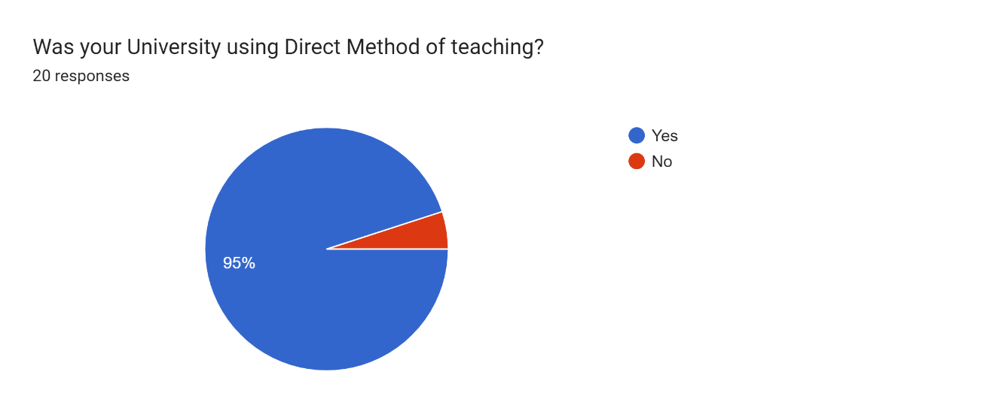

Figure 2.The ratio of GTM & Dm at the University Level

As the results demonstrate that most learners learn the English language through the direct methods in the universities, thus after being exposed to the direct method for 4-5 years they get aquatinted to the direct method and when they get appointed as secondary school teachers, they feel uncomfortable with using GTM.

Among the Participants, 80 % suggested that secondary schools should use the Direct method of Teaching English, while 20 % of participants favored the Grammar Translation method for English Language Teaching at Secondary schools.

Figure 3. Suitability of GTM & DM at the school level

A gap is created when the knowledge input is given in the Direct method but in professional life, the teachers are supposed to teach through the grammar-translation method. The teachers then struggle with translation, as the data demonstrated. To overcome this problem 50% of the respondents have suggested that the Universities should adopt GTM so there can be harmony in the teaching methodologies of input and output, and 10% of respondents suggested that schools Should adopt Direct Methodology. The other 40% of respondents suggested that teachers should be properly trained for GTM before standing in the class so they can be comfortable with it. This was an ending question of the questionnaire but since we have grouped it with the close-ended question that’s why it is placed here.

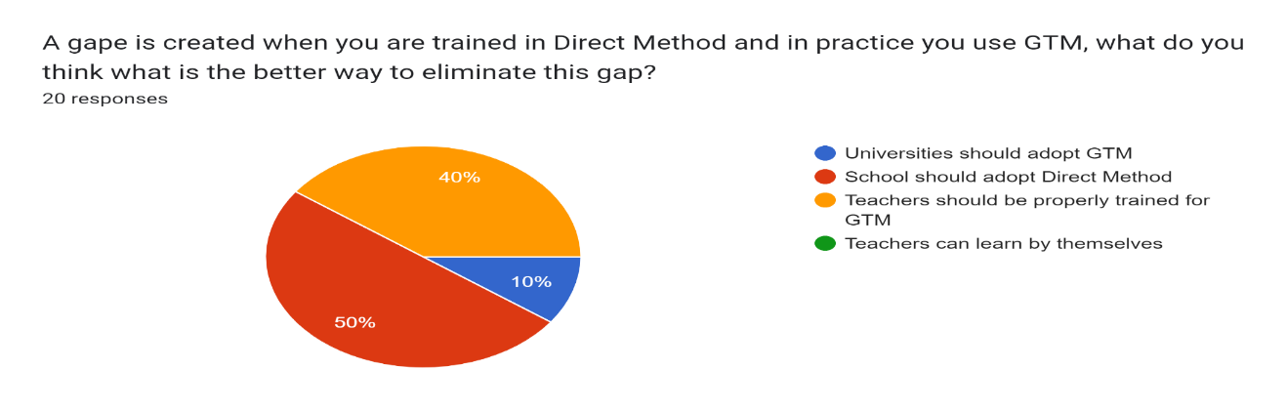

Figure 4. Suggestions for Eliminating the problems of teachers

### Open Ended questions

Some open-ended questions were added to the questionnaire to get versatile and diverse data. Open-ended questions give the space to the fullest expression of thoughts. In response to those open-ended questions, we have got interestingly diverse data. To give those responses a statistical shape we have grouped those answers which had the same core idea. The questions and the ratio of responses are listed as under.

**The first question among open-ended questions was ‘****Which method of teaching is more effective in ELT, the Grammar Translation Method, or the Direct Method? And why?’.**

In response to this question 10 participants found the Direct method effective because they feel that the direct method produces fluent and good speakers, one of the respondents stated, “Direct Method because a stage will come when students automatically cope up with language issues and it is also psychologically proven.” They stated that the direct method is easy and more practical and thus more effective as stated one of the respondents “Direct Method, also the drills and practices because the more the students practice a language the more, they effectively learn.

Among all, 20% of the participants selected GTM as an effective method for English language teaching at the secondary level and their reasons for that were the easiness and comfortability of the students in their native language. The participants asserted the “Grammar translation method because students in this area are very weak in English so they face difficulty in understanding foreign language “and the “Grammar Translation Method because we feel comfortable with our native language which helps us in better understanding”.

However, 10% of the respondents expressed their interest in the mixed method where the teacher would use GTM and DM together according to the need of the classroom. They stated that “For English as Subject GTM is effective while for English as a language DM is effective”

Amazingly, 20% of the participants even did not respond to the question which infers that probably they were not aware of the effectiveness of any method, or they possibly didn’t find any of these two methods effective for the English Language classroom.

Looking at the overall responses to the above question which represent the perception of the novice teachers towards GTM in terms of its effectiveness in the classroom, we can conclude that GTM is perceived by them to be less effective in attaining the aims of an EL class as compared to the direct method.

Figure 5 Effectiveness of GTM and DM

**The second question was** **“What are the problems you face in ELT classrooms?”**

This question asked the teachers about the problems they faced as new teachers in a secondary school classroom. The answers to this question were also very diverse and different. We have grouped similar answers to drive its statistical data.

Being beginners in teaching, 35% faced problems in translating English into Urdu. The contrast between literal and contextual meaning has been one of the most prominent problems as pointed out by the respondents “Literal translation of passages by deducing literal and contextual meanings of words is tricky”. Besides them, the other 20% of respondents answered that they found the switching of teaching from the direct method to GTM difficult as a whole. Hence translation difficulty is also faced due to the change of teaching method from Direct method to GTM, thus we can say that overall, 55% of teachers struggle due to the change in teaching method from DM to GTM. Among the remaining participants, 40% were facing the issue of enhancing and conforming to the understanding level of the students in the target language according to the school’s standards. However, 5% did not respond to the question.

Figure 6.Problems of ELT classroom

Thus, it is inferred from the responses that more than half of the novice secondary school teachers struggle with the implantation of GTM and translating English into Urdu or English because they had themselves learnt English in English rather than Urdu or Pashto.

**The third question was** “**Did you feel any difficulty in translating English into Urdu or Pashto? if yes then how?”**

In response to this question, 16 participants counting 80% of the total participants affirmed that they face difficulty while translating the text from English into Urdu or Pashto and their reasons were the difference between lexical and contextual translation, the linguistic and cultural gaps between English and Urdu or Pashto, and also because they were instructed in Direct method in the universities, and they are not accustomed to translation. In this regard, some of the responses are “Yes, because language barriers exist in every language and contextual as well as literal meanings do differ”, “Yes always. Because there is always a difference between a literal translation and the denotative ones. Some lines can't be exactly translated”, and “yes I face difficulty while translating English into Urdu because we are used to direct method and it becomes difficult for me to convey my message properly in Urdu”.

On the other hand, 20% which counts 4 out of 20 teachers did not encounter any problem when they were translating English into Urdu or Pashto.

Figure 7. Difficulties in translation

In sum, among 20 novice English teachers 16 which make up 80% encountered problems in translation for the reasons stated above. The translation is a coral technique of the GTM thus we induce GTM from translation to state that 80% of university-graduated novice English teachers find the GTM difficult.

**Conclusion**

Grammar translation method and direct methods are the prominent methods of teaching English in an EL classroom. In Pakistan’s education system, a transition takes place between these two methods in a binary way. Firstly, when the students start schooling, they are inducted through GTM at the school level but when they reach the university level the induction or the teaching method switches to the direct method and the advanced level English learning takes place in the direct method. After graduation when these students become teachers and some of them get appointed as secondary school English teachers, a sudden transition takes place in the teaching method from DM to GTM. This sudden transition creates difficulties for these novice teachers in implementing GTM in classrooms. This paper analyzed those difficulties by investigating how many novice teachers encounter problems in using GTM in the classroom, what kind of problems they face and what are the reasons for facing those problems. For this purpose, the data was collected through a questionnaire and was analyzed quantitatively by using percentages. The analysis and the results show that among a total of 20 participants, 95% were inducted through DM in their universities while 80% of the schools where they teach use GTM. 80% of the participants opined that schools should use the direct method of teaching because it is more effective for language learning and convenient for teachers. Due to the sudden change in the methodology, 55% of the participants were facing problems in using GTM and translating texts from English to Urdu or Pashto because they were not habitual to GTM and due to a huge linguistic and cultural gap between the English and Pakistani context. Most teachers suggested that a Direct Method should be applied in schools to uplift the learners’ proficiency in the target language and make the system in conformity with teacher’s education however some suggested that training in GTM can help in overcoming this gap. The teachers should be trained for GTM before confronting the class.

**References**

Akramy, S. A., Habibzada, S. A., & Hashemi, A. (2022). undefined. Cogent Education, 9(1). <https://doi.org/10.1080/2331186x.2022.2127503>

Areeba Arif, Syeda Sarah Junaid, Salma Niazi. (2021). Effective teaching methodology for teaching English as a second language at tertiary level. Pakistan Journal of Educational Research, 4(4). <https://doi.org/10.52337/pjer.v4i4.346>

Chellapan, K. (1982). Translanguage, translation and second language acquisition. Papers on translation: Aspects, concepts, implications, 57-63.

Dueñas Vinuesa, M. (2002). Diane Larsen-Freeman. 2000. Techniques and principles in language teaching. Second edition. Oxford: Oxford University press. 189 pp. Journal of English Studies, 3, 277. <https://doi.org/10.18172/jes.83>

Ellis, R. (2006). undefined. TESOL Quarterly, 40(1), 83. <https://doi.org/10.2307/40264512>

Elmayantie, C. (2015). The use of grammar translation method in teaching English. Journal on English as a Foreign Language, 5(2), 125. <https://doi.org/10.23971/jefl.v5i2.372>

Farrell, T. S. (2012). Novice-service language teacher development: Bridging the gap between Preservice and in-service education and development. TESOL Quarterly, 46(3), 435-449. <https://doi.org/10.1002/tesq.36>

Kershaw, G. (2002). Teaching and learning in the language classroom. T. Hedge. ELT Journal, 56(3), 337-341. <https://doi.org/10.1093/elt/56.3.337>

Hedge, T. (2001). Teaching and learning in the language classroom (Vol. 106). Oxford, UK: Oxford university press.

Khan, A. B., Mansoor, H. S., & Manzoor, S. (2016). The effectiveness of grammar translation method in teaching and learning of English language at intermediate level. International Journal of Institutional & Industrial Research, 1(1), 22-25.

Sözen, P. H. (2019). Challenges of novice teachers. IJAEDU- International E-Journal of Advances in Education, 278-282. <https://doi.org/10.18768/ijaedu.478254>